# C++ MATH:

1) Max and min

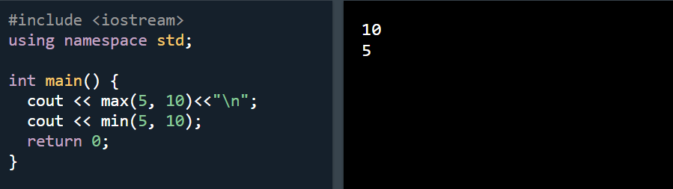

2) C++ <cmath> Library

Other functions, such as sqrt (square root), round (rounds a number) and log (natural logarithm), can be found in the <cmath> header file

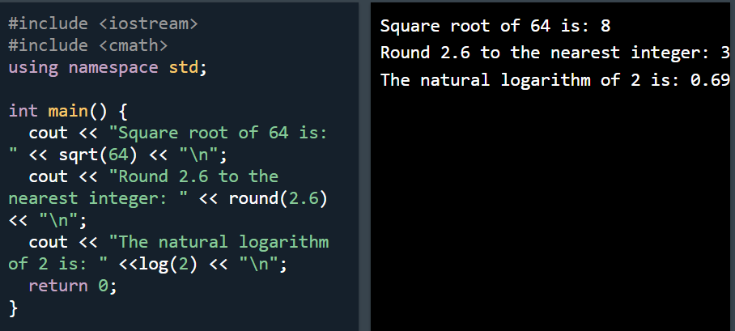

# C++ Booleans

1. Boolean value

2) Boolean Expression

The Bool is not written here however the computer will think of it as bool and give either 1 or 0 as output

Practice 01:

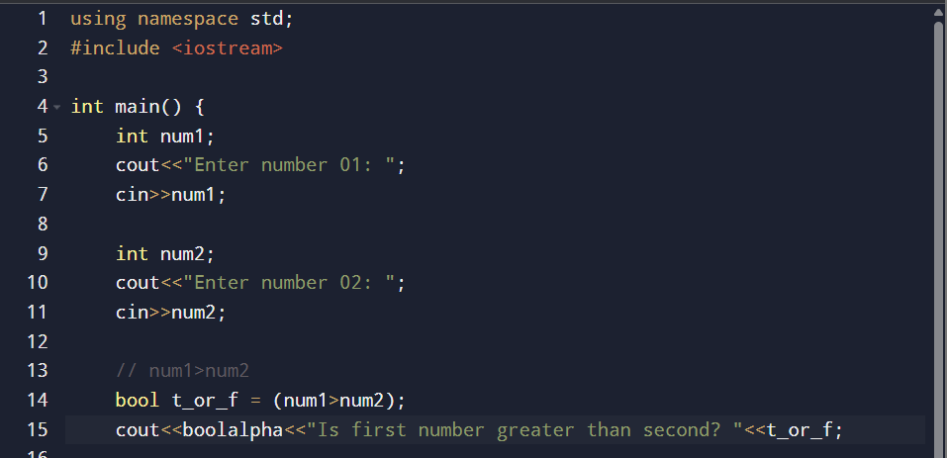

Practice 02:

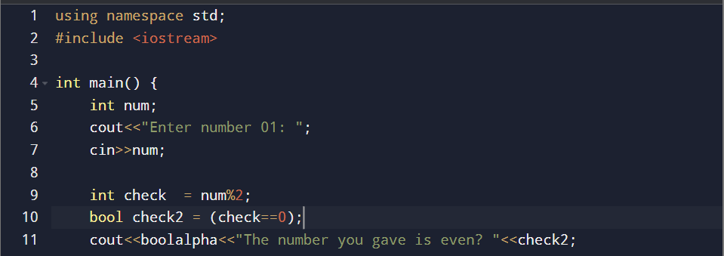

Practice 03;

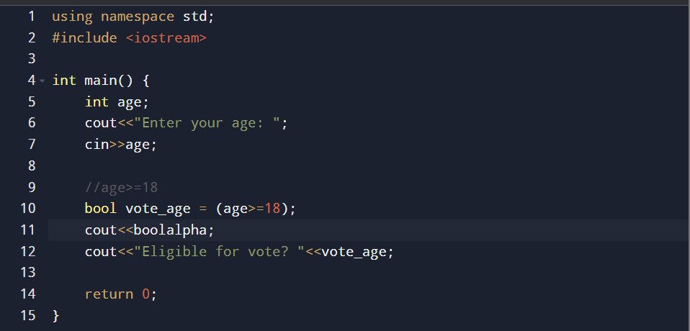

Practice 04;

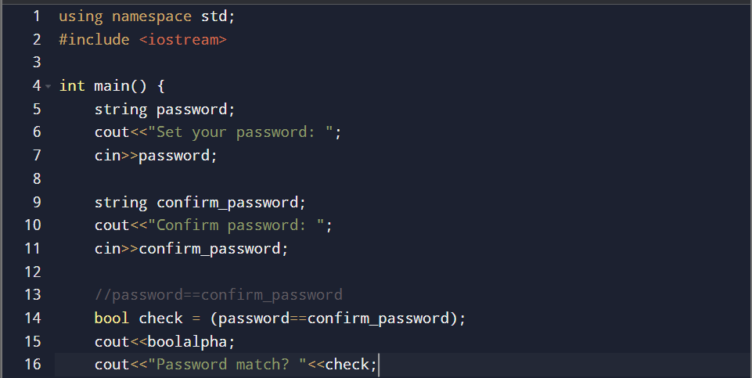

Practice 05:

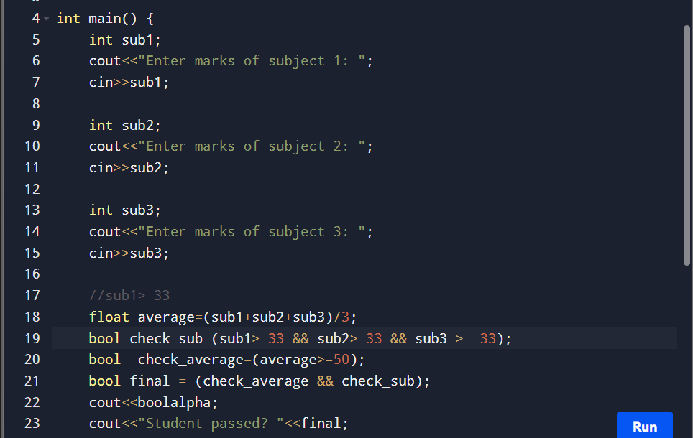

Task 01:

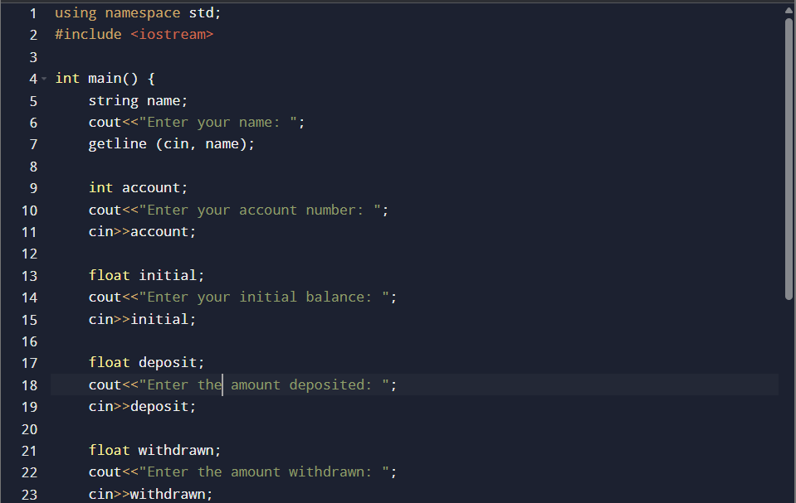

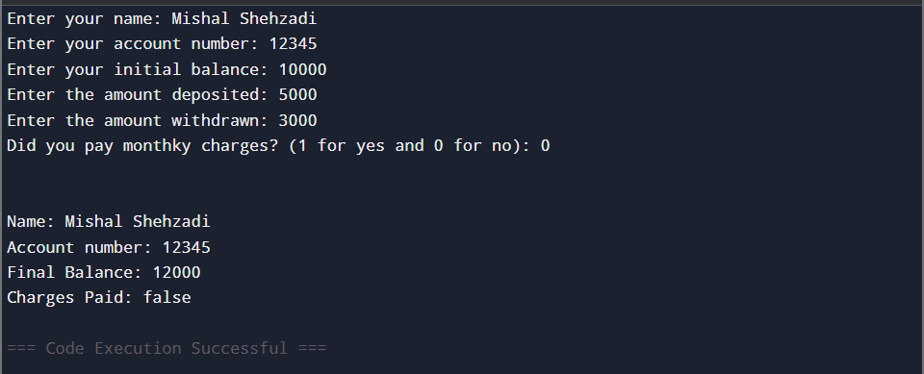

Task 02:

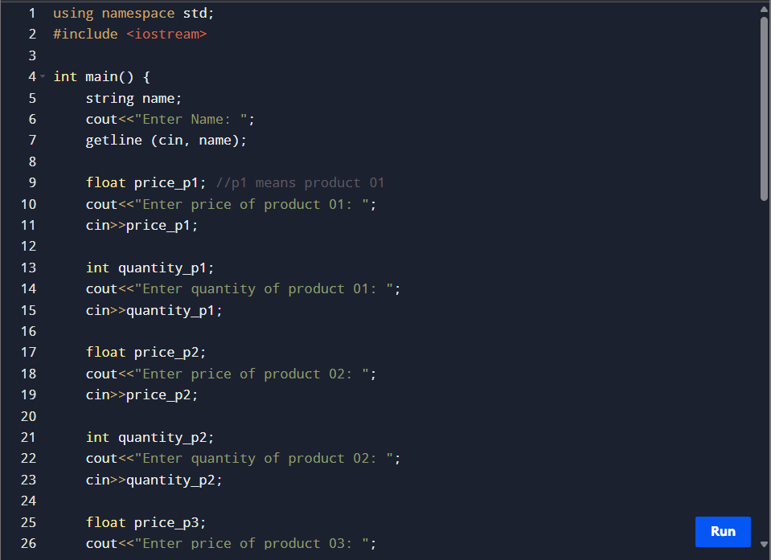

Task 03:



